

Laxman Dutt Degala | KDM – CS560 | February 4, 2014

Lab 2 Assignment

Mobile application – Weather Compare

Application details:

This application would take the address/zip code as input and retrieves temperature details from two different weather service providers. Google & Geonames.

Sources used:

HTML5, CSS3, Javascript, Jquery, AJAX, JSON.

Future plan:

As discussed with Lee the other day, Plan is to use all the Google services and make the page a ONE-STOP for everything (Weather, Landmarks, Coffee shop, Restaurants, Nearest Places to visit etc), when user enters an address in the input.

Steps involved:

Step 1:

Used Google APIs (Google maps & Google weather services), merged both the services and retrieve Temperature for a given “Address or Zipcode” in Input.

Step 2:

Latitude and Longitude values are also retrieved from step 1 and is used to retrieve temperature using other weather service provider, Geonames in our case.

Step 3:

Temperature details from geonames is retrieved using Restful/JSON services.

Step 4:

Temperatures are compared to see the delta difference

Snapshots:

1. This is how home page looks like:

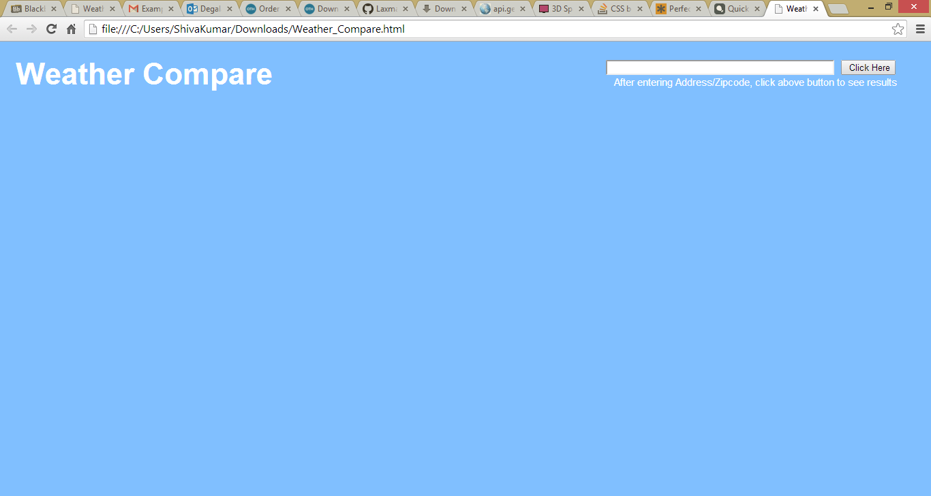

1. We can either enter Address or Zipcode

Have entered ‘Kansas city’

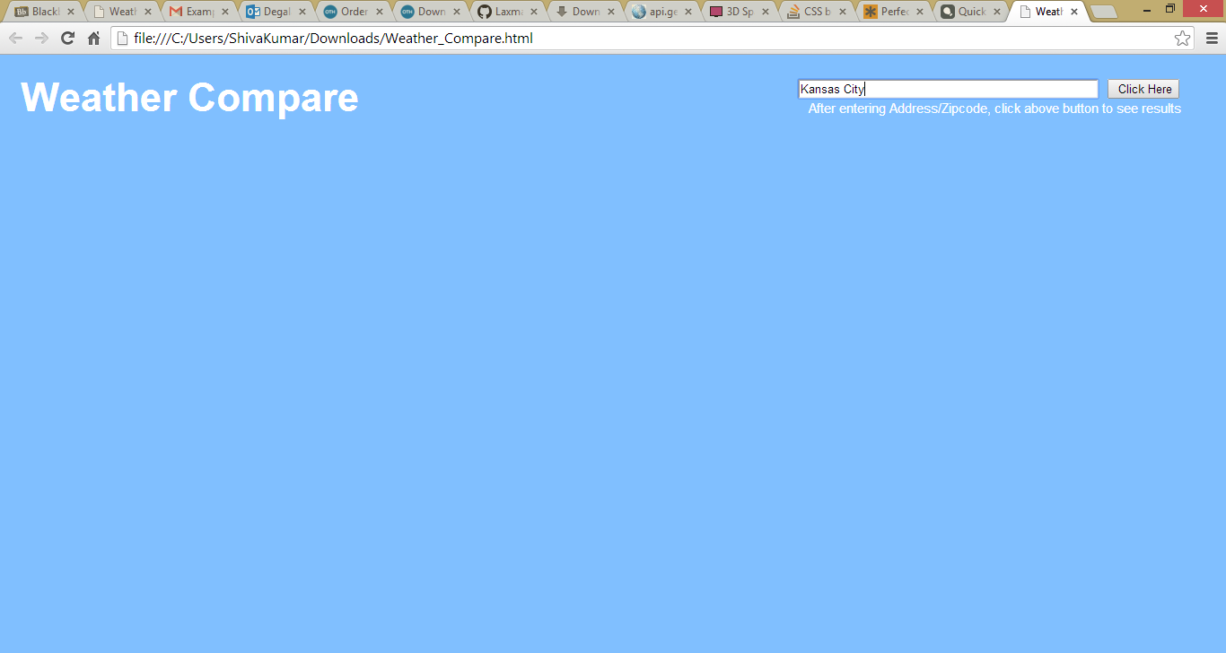

Result is:

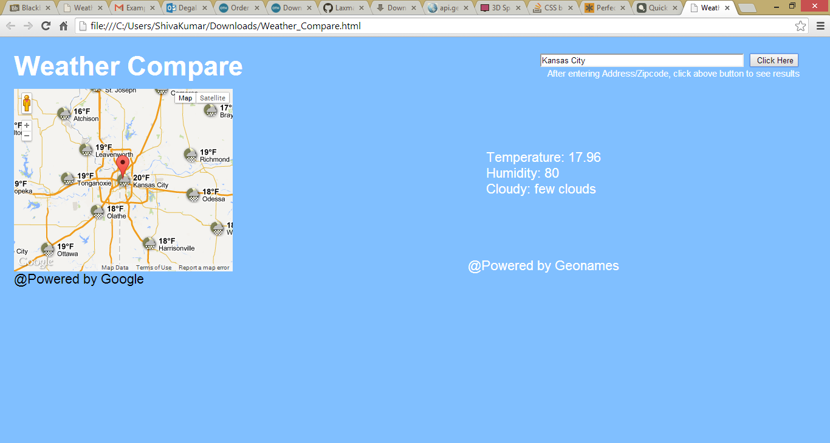

1. Have entered “64110”

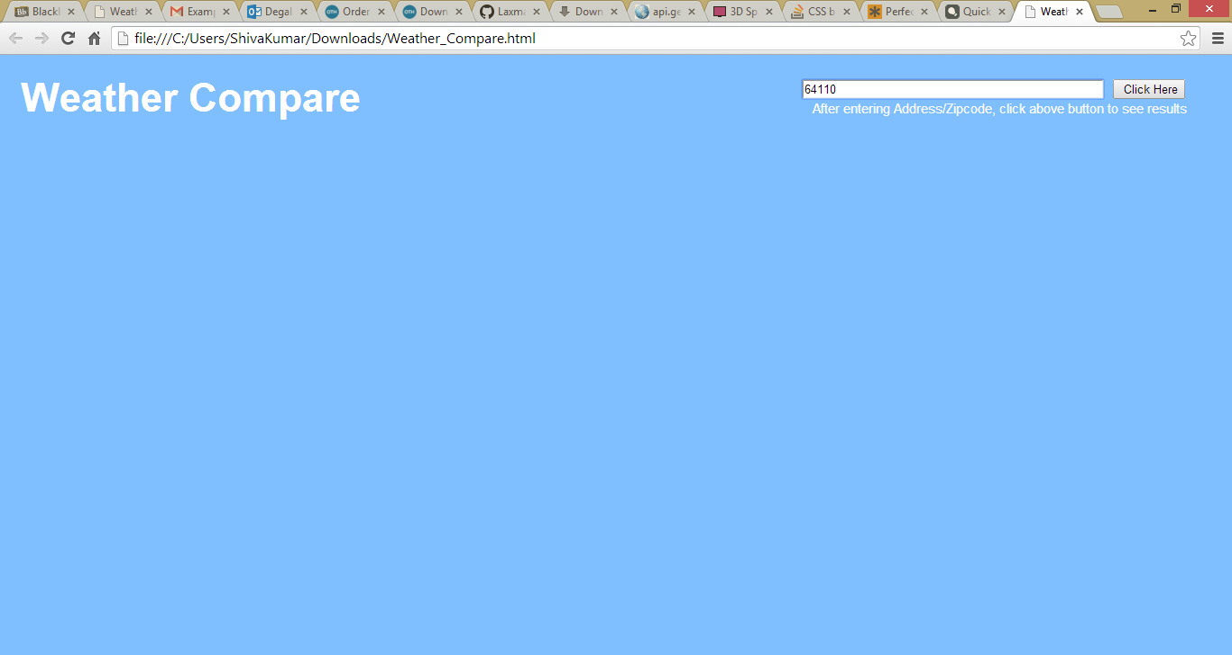

**Result is:**

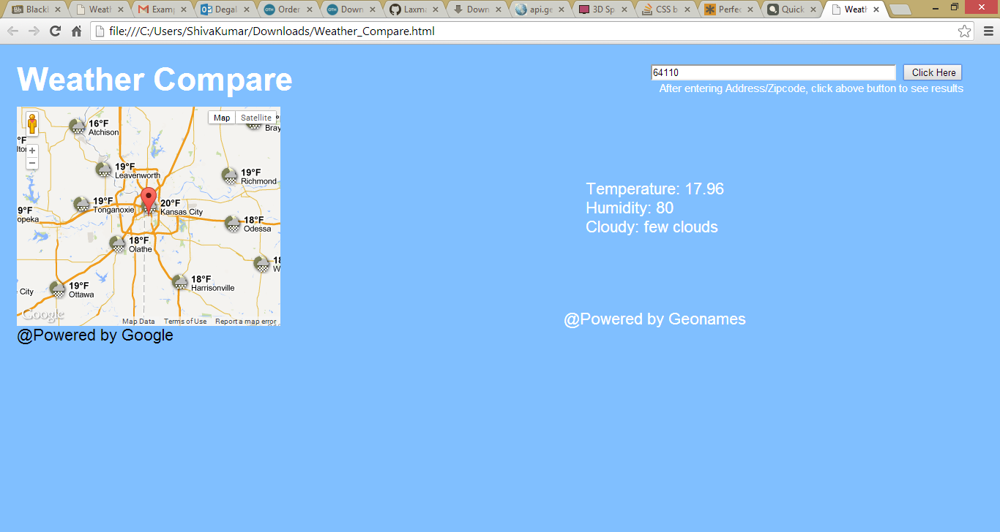

1. Both the results looks good & the delta difference is 1.5 F.